# **Brain Break**

### I am trying to practice mindfulness. Shocker, I know.

Zoe's avatar

[Zoe](https://substack.com/@zoeffc)

Nov 01, 2024

Share

Hi there!

I have been so scattered lately. I have big project deadlines at work and am still learning the ropes at my new job. So, in an effort to come back down to earth and remember that I am both a brain AND a body, I am challenging myself to expand my mindfulness practice.

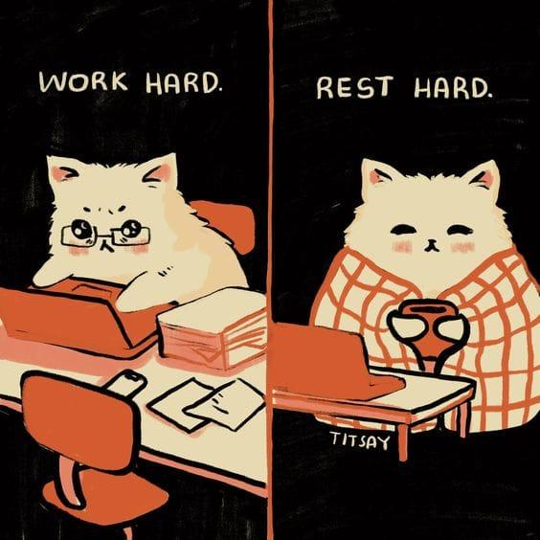

First some housekeeping:

📫 If a friend forwarded you this newsletter (then you have some really cool friends), and you may want to consider joining us here for regular updates.

[Subscribe](https://femme-futures.beehiiv.com/subscribe)

🧲 Got some thoughts you want to share? Join us on Discord to chat all things newsletter and corporate life.

[Discord](https://discord.gg/N84WxemQ?utm_source=femme-futures.beehiiv.com&utm_medium=referral&utm_campaign=brain-break)

You can find all archived newsletters at the online site, if you ever want to go back or if you just feel like perusing.

[Check out the website](https://femme-futures.beehiiv.com/)

When I say that I want to “expand” my practice, please know that I am starting at a pretty low baseline. That is to say, I know what mindfulness is and will occasionally grab 5-10 minutes of meditation when I am in crisis mode. It is not a routine or habit in my life by any means. Honestly, I am not even sure that I believe in its effectiveness for me.

November is promising to be a hard month work-wise, and I already struggle to slow down. At deadline times, my adrenaline kicks in and I stop paying close attention. It’s when I make mistakes and embarrass myself. (Literally today, oh my god. Will I never learn this lesson?) On the other hand, as you have probably been able to tell from my previous notes, I take pride in being recognized as good at what I do. Efficiency earns you major kudos in the corporate world — mistakes do not. It’s a tricky balance.

I know that, theoretically, I can slow down and not be seen as a bad worker. The challenge this month is to prove that to myself. I can almost guarantee that I will make many fewer mistakes when I intentionally step away from a task after I’ve completed it and before I’ve delivered it. Giving myself one last check with a clearer mind will help me.

So how do I achieve this clearer mind?

1. Recognizing it in the moment and “micro-dosing mindfulness”. This month, I want to practice coming back to my breath and body when I feel myself getting flustered. Other good practices for me include getting some sunshine and moving my body.
2. Daily meditation. I am going to try to sit and meditate for at least 10 minutes a day every day this month.
3. Do not absorb the emotions of others. I am not the only one at work who is running on adrenaline at the moment. It is so easy to mirror the energy of those around you, and if that energy is frantic, that’s not helpful for me.

Wish me luck! (And if any of you are inspired to try a similar challenge, reach out! I need accountability buddies.)

Best,

Zoe

P.S. I am kind of loving that this is a much shorter note than usual. I think it reflects just how scattered I am that even writing this needs to be a short burst.

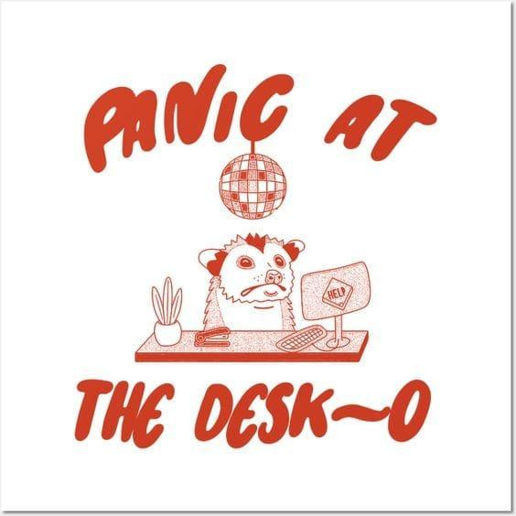

*Artist Unknown*

**Femme Futures Cooperative Founding Principles**

💚 **Mission**: The mission of Femme Futures is to create a community space for young professionals who identify as over-achievers and activists to generate collective success by providing resources and platforms to thrive in challenging workplace environments.

💙 **Vision**: To contribute to a world where driven individuals are equipped with the tools, guidance, and connections to overcome systemic barriers, fully utilize their talents, and enact positive change in their organizations and communities.